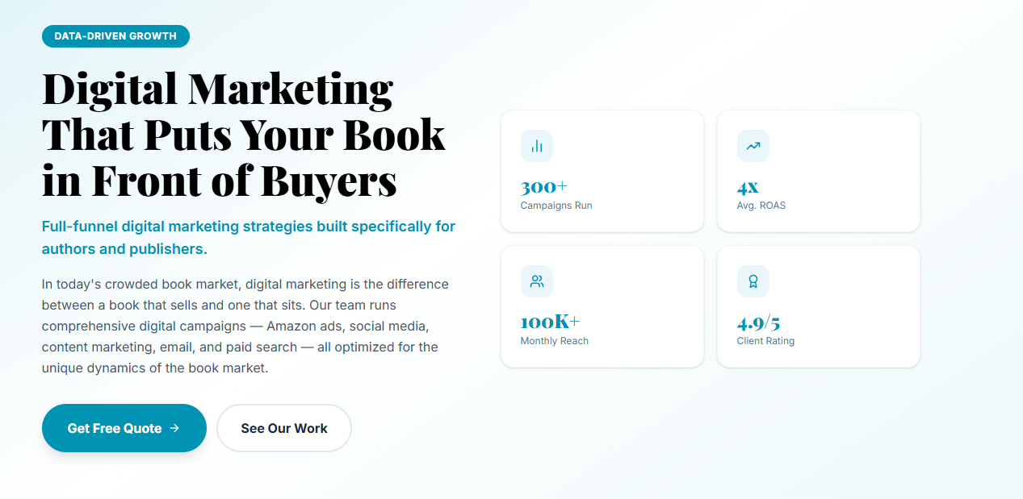
Section 1 — Hero
Eyebrow: DIGITAL MARKETING
H1: Digital Marketing for Authors That Turns Scrolls Into Sales
Subtext: We take responsibility for ads, content, and results tracking so that your book gets to its intended audience while you just have to write.
Paragraph: These days, readers often find their next book through social media, search, or email. Our book digital marketing services bring ads, social media, content, email, and SEO together to help more of the right people discover your book.
CTA: Get a Free Quote | See Our Work
Highlight Card 1: Campaigns Built for Your Genre
Highlight Card 2: Ads Aimed at Real Readers
Highlight Card 3: Budgets Managed With Care
Highlight Card 4: Clear, Honest Reporting
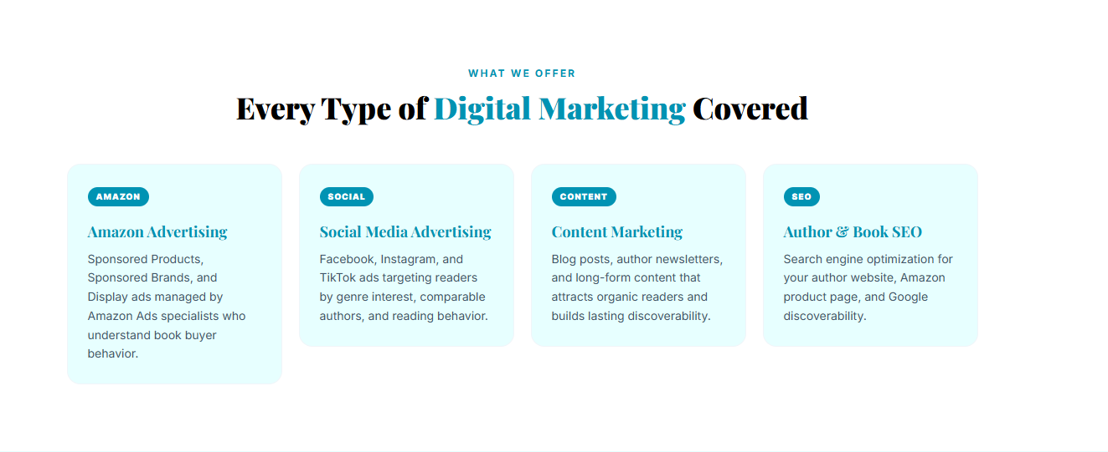
Section 2 — What We Offer
Eyebrow: WHAT WE OFFER
H2: Every Platform Your Readers Scroll, Covered
Subtext: We focus on the platforms where your readers already spend their time, and we make every channel work toward the same goal: selling more books.
AMAZON
Amazon Advertising
Sponsored Products, Sponsored Brands, and Display ads managed by specialists who understand how book buyers search, browse, and decide what to read next.
SOCIAL
Social Media Marketing
Our social media marketing for authors covers Instagram, TikTok, Facebook, and Pinterest. We create content that feels like you, helps people get to know your work, and keeps your books in front of readers.
ADS
Facebook & Instagram Ads
We run Facebook and Instagram ads for people who are interested in what you write about, like certain authors and genres of books. We want to make sure that you reach the right audience, the one who will be interested in reading your book.
CONTENT
Content & Email Marketing
From blog posts and author newsletters to email campaigns, we create content that keeps readers connected to you and gives them a reason to come back when you have something new to share.
SEO
Author & Book SEO
We optimize your author website and book pages so readers can find you on Google and Amazon, even when you’re not running ads.
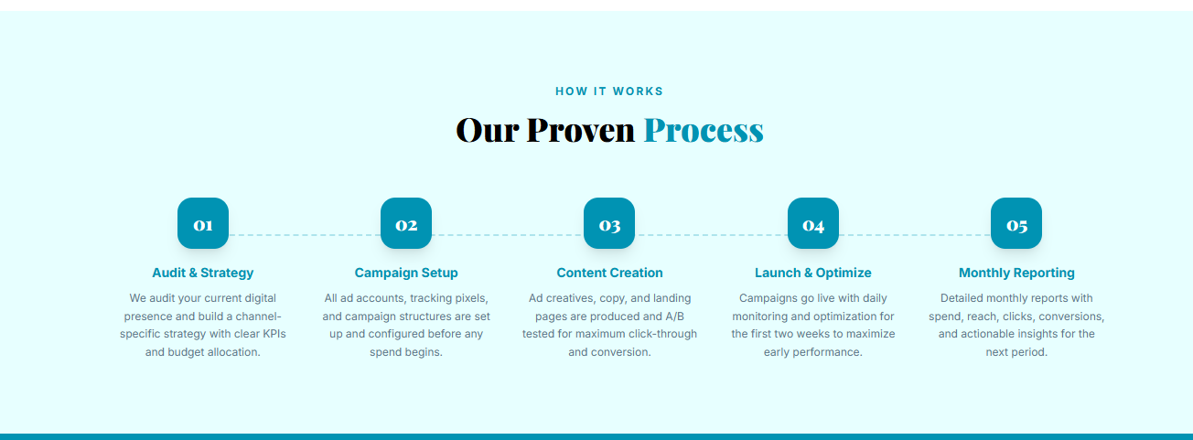
Section 3 — How It Works
Eyebrow: HOW WE GROW YOUR READERSHIP
H2: Four Steps From Scroll to Sold
Subtext: A clear, organized process so you always know where your budget is going and what it’s bringing back.
01 — Complimentary Consultation:
Tell us about your book, your readers, and your budget. We review your current online presence and build a digital marketing strategy for authors with clear goals for every channel.
02 — Writing & Editing:
Our team writes your ad copy, social posts, email sequences, and website content. Every piece is edited to match your voice and speak directly to the readers you want to reach.
03 — Design & Formatting:
We design ad creatives, social graphics, and landing pages, all formatted for every platform and screen size so your book looks great wherever readers see it.
04 — Publish & Launch:
Your campaigns go live with tracking in place from day one. We monitor performance closely, adjust what isn’t working, and send you regular reports so you always know how your book is doing.
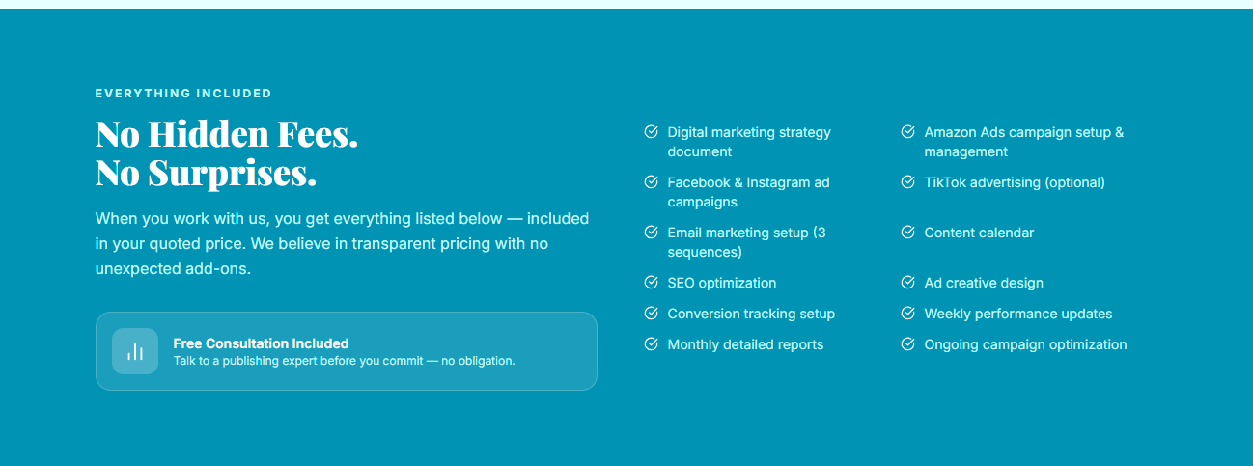
Section 4 — What’s Included
Eyebrow: WHAT’S INCLUDED
H2: Strategy, Ads, Content, and Reports. All Included.
Your quote includes everything listed below, from strategy and content to reporting. You’ll know what you’re paying for from the start, with no surprise costs added later. A digital marketing strategy built for your genre and goals
- Amazon Ads campaign setup and management
- Facebook and Instagram ad campaigns
- Social media content calendar
- Email marketing setup
- Author website and book SEO
- Ad creative design and copywriting
- Conversion tracking setup
- Regular performance updates
- Monthly detailed reports
- Ongoing campaign optimization
- A dedicated project manager as your single point of contact
Callout Box:
Free Consultation Included. Talk to our team about your book and your budget before you commit. No obligation, no pressure.
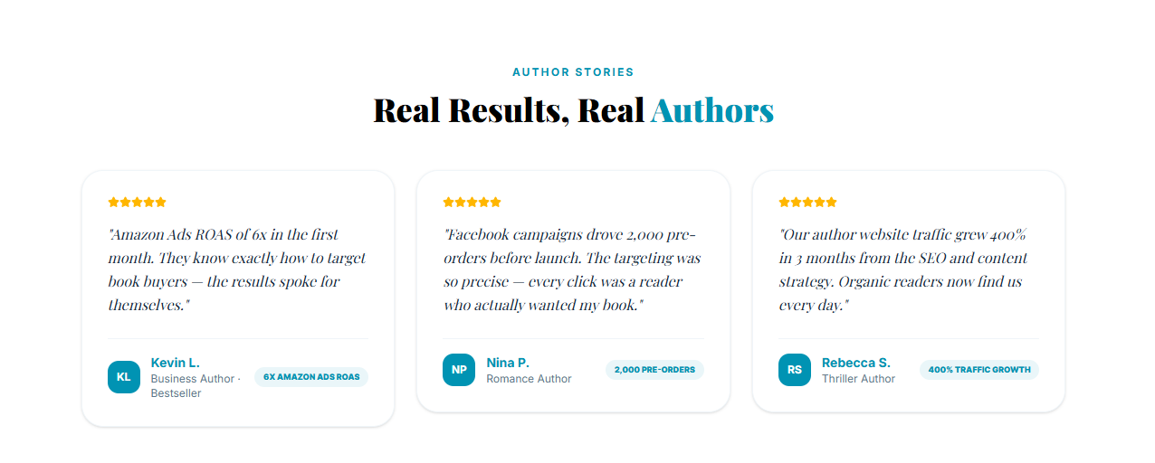
Section 5 — Testimonials
Eyebrow: AUTHOR STORIES
H2: What Authors Say After the Reports Come In
Subtext: In their own words, from authors who trusted us to grow their readership online.

Review 1
★★★★★
"I had been trying to advertise my own book through ads, but I did not know what was actually working for me. This team helped me figure out my market, sorted out my campaigns, and provided me with a clear direction for my entire launch process."
Sarah M.
Fiction Author

Review 2
★★★★★
What really struck me about the marketing was the focus on my particular genre. Everything seemed to tie together, not just marketing techniques but everything else, too. I noticed that people were showing an interest in my novel and visiting my author page.”
Daniel R.
Business Author

Review 3
★★★★★
“I’m a writer, not a marketer, so trying to stay on top of advertising, social media, and analytics was getting to be too much. They handled that for me while still making sure I knew what was going on. It left me with a lot more time for writing.”
Emily K.
Non-Fiction Author
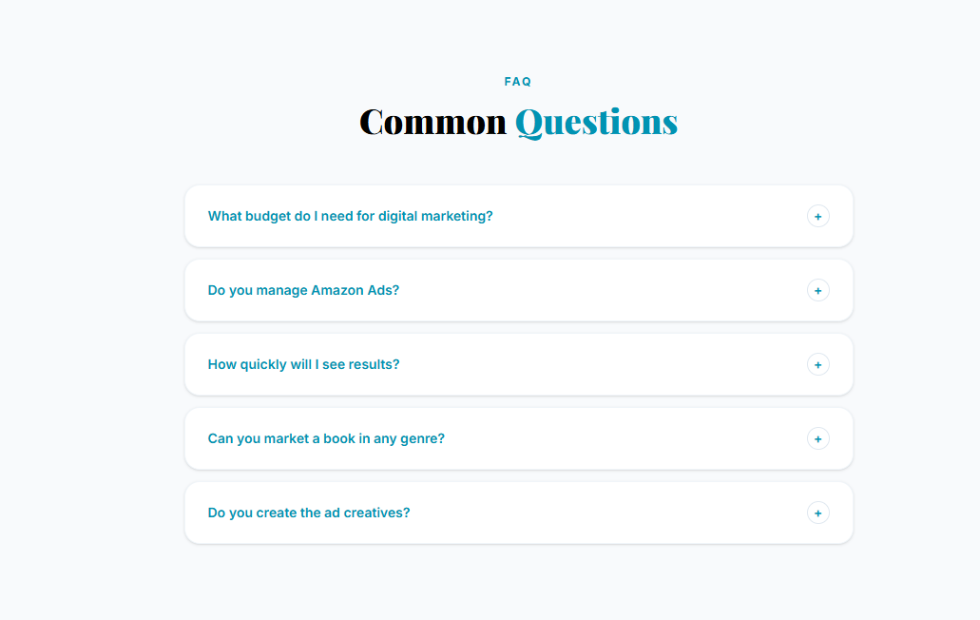
Section 6 — FAQ
Eyebrow: FAQ
H2: Everything You'd Ask Before Your First Campaign
What budget do I need for digital marketing?
This is based on what you want, what you write, and how we distribute it. We will advise on a budget that fits your book in your consultation, and we will never try to force you to spend more than you wish.
Do you manage Amazon Ads?
Yes. We handle keyword research, campaign setup, and ongoing management, adjusting your ads based on performance so your budget goes toward what’s working.
Do Facebook ads work for books?
They can work very well when they’re targeted properly. Our Facebook ads for authors focus on readers who already enjoy your genre or similar authors, which helps keep costs down and sales steady.
How quickly will I see results?
Some campaigns generate clicks and conversions within a couple of weeks, while SEO and content marketing take time to develop. We will set realistic expectations from the beginning and update you on our progress as we go.
Can you market a book in any genre?
Yes. We work with fiction, non-fiction, business, memoir, and children’s books, and we tailor every campaign to the readers of that genre.
Do you create the ad creatives?
Yes. Our team writes the ad copy and designs the visuals, then tests different versions to see which ones bring in the most readers.
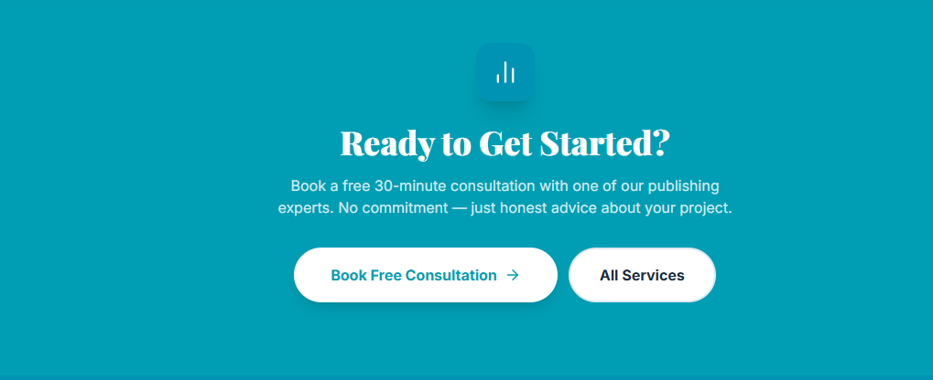
Section 7 — Final CTA
H2: Your Readers Are Scrolling. Let's Make Them Stop.
Subtext: Book a free consultation with our team. We’ll look at your book, talk through your goals, and give you an honest picture of what it will take to grow your readership online.
CTA: Book a Free Consultation | Explore All Services

